

SB-3

Signal Booster

Users Guide

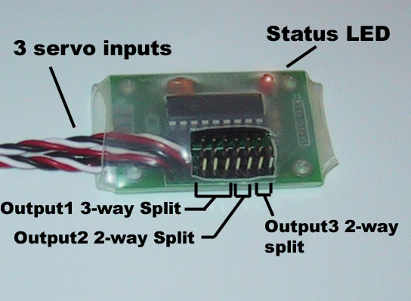

Installation
The SB-3 can boost up to 3 RC signals. The three servo cables attached to the board are numbered 1,2 and 3 from left to right on the board. The signal from cable #1 is output on the first three output headers as shown in the photo above. The signal from cable #2 is output on the fourth and fifth output headers and the signal from cable #3 is output on the sixth and seventh output header.

Simply plug the SB-3 servo cables into your RC-receiver and plug the devices you want to control (e.g. speed controllers) into the output headers on the SB-3. All connectors should be oriented so that the ground wire (black) is near the bottom edge of the board.

If you have purchased a remote LED for your SB-3, it plugs into the two-pin connector on the top-right corner of the board. Use the included mounting grommet to mount the LED in a ¼” mounting hole in your robot.

LED Status Indicator
The LED on your SB-3 signal booster can be used to verify proper operation. Its behavior indicates one of the following 3 states:

LED Behavior | Signal Status
Off | No power
On – Solid | Valid signal detected
On – Slow Blinking | Invalid signal or no signal detected

The SB-3 monitors the RC signal status on its first input channel so if you are not using all three inputs, make sure you do connect input #1 to your receiver.

Also, note that if you have a PCM reciever with a programmable failsafe, once your transmitter is powered up, the receiver will continue to output a clean signal to the booster board even after you power down your transmitter thus causing the SB-3 light to stay on solid.

Wiring Diagram

Remote LED (optional)
Mount in 0.25” hole.

RC Receiver

SB-3 Signal Booster

Devices Connect Here

Acknowlegements

Special thanks to our beta testers: Ed McKnight, and Terry Wynn! Ed, congratulations on your win in the 30lb class at LVSF5!

LEGAL DISCLAIMER:

THIS PRODUCT IS PROVIDED "AS IS" WITHOUT ANY EXPRESS OR IMPLIED WARRANTY OF ANY KIND INCLUDING WARRANTIES OF MERCHANTABILITY, NONINFRINGEMENT OF INTELLECTUAL PROPERTY, OR FITNESS FOR ANY PARTICULAR PURPOSE. IN NO EVENT SHALL ROBOT LOGIC OR ITS SUPPLIERS OR DISTRIBUTORS BE LIABLE FOR ANY DAMAGES WHATSOEVER (INCLUDING, WITHOUT LIMITATION, DAMAGES FOR LOSS OF PROFITS OR BUSINESS INTERRUPTION) ARISING OUT OF THE USE OF OR INABILITY TO USE THE MATERIALS, EVEN IF ROBOT LOGIC HAS BEEN ADVISED OF THE POSSIBILITY OF SUCH DAMAGES. BECAUSE SOME JURISDICTIONS PROHIBIT THE EXCLUSION OR LIMITATION OF LIABILITY FOR CONSEQUENTIAL OR INCIDENTAL DAMAGES, THE ABOVE LIMITATION MAY NOT APPLY TO YOU.
Robot Logic and its suppliers further do not warrant the accuracy or completeness of the information, text, graphics, links or other items contained within product datasheets or this website. Robot Logic may make changes to these materials, or to the products described therein, at any time without notice. Robot Logic makes no commitment to update the Materials.

